Experiment:- 7

Problem statement:-
Linux is a multi-user operating system where multiple users can access system resources simultaneously. Proper user and group management is essential to ensure system security, controlled access to files, and efficient administration. Cyber security professionals must understand how Linux manages users, groups, ownership, and permissions to prevent unauthorized access and enforce security policies.
The problem is to create, modify, and manage users and groups in Linux, understand file ownership and group permissions, and practice sharing files securely between users and groups.

Aim:- Managing users and groups in linux.

Procedure:-
- Log in to the Linux system. Open the terminal.
Create a new user: sudo useradd testuser sudo passwd testuser

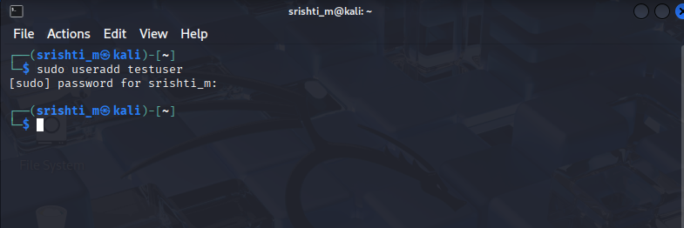

- Verify the user: id testuser

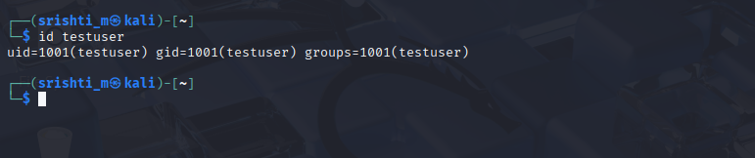

- Create a new group: sudo groupadd testgroup

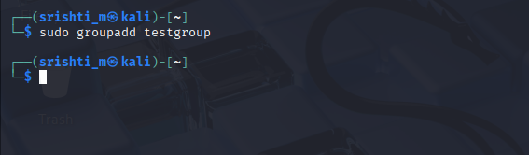

- Add user to the group: sudo usermod -aG testgroup testuser

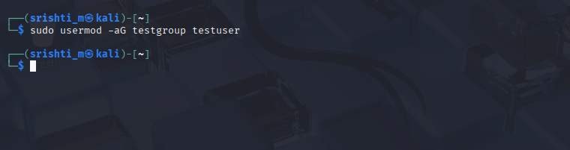

- Check user group membership: groups testuser

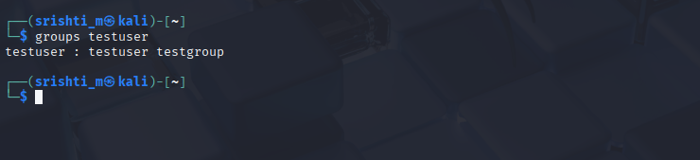

- Create a shared directory: mkdir shared_dir
sudo chgrp testgroup shared_dir
sudo chmod 770 shared_dir

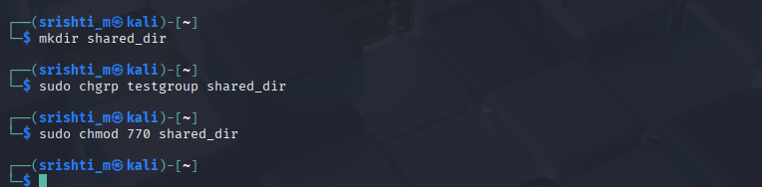

- Apply sticky bit: sudo chmod +t shared_dir

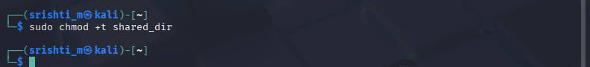

- Change file ownership: sudo chown testuser:testgroup shared_file.txt

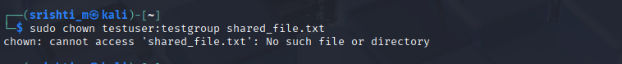

Expected Output

• New users and groups created successfully.
• Users added to groups correctly.
• File and directory ownership modified.
• Shared directory protected using sticky bit.

Result

Linux user and group management operations were successfully performed. The student learned to control access to system resources using users, groups, permissions, and special access bits.

